IOT Based Heart Monitoring System Using ECG
The Embedded technology has entered almost in all aspects of day-to-day life, and the healthcare field is no exception for that the requirement for fully-equipped hospitals and diagnostic centers growing day by day as people are becoming more unaware of their health problems. An ECG signal can trace various physiological and abnormal conditions of the heart. This heart monitoring system also helps to inform the person whether he/she has any heart diseases or not. This is done by checking the heart beat level. In this system Atmega controller is used to scan ECG signal and search for pattern in common range, if the pattern will be in common range then it gives the report of being normal if it is found that the is not in common range then the person is suffering from some kind of heart disease. The following result is sent as message on IOT.

Block Diagram:
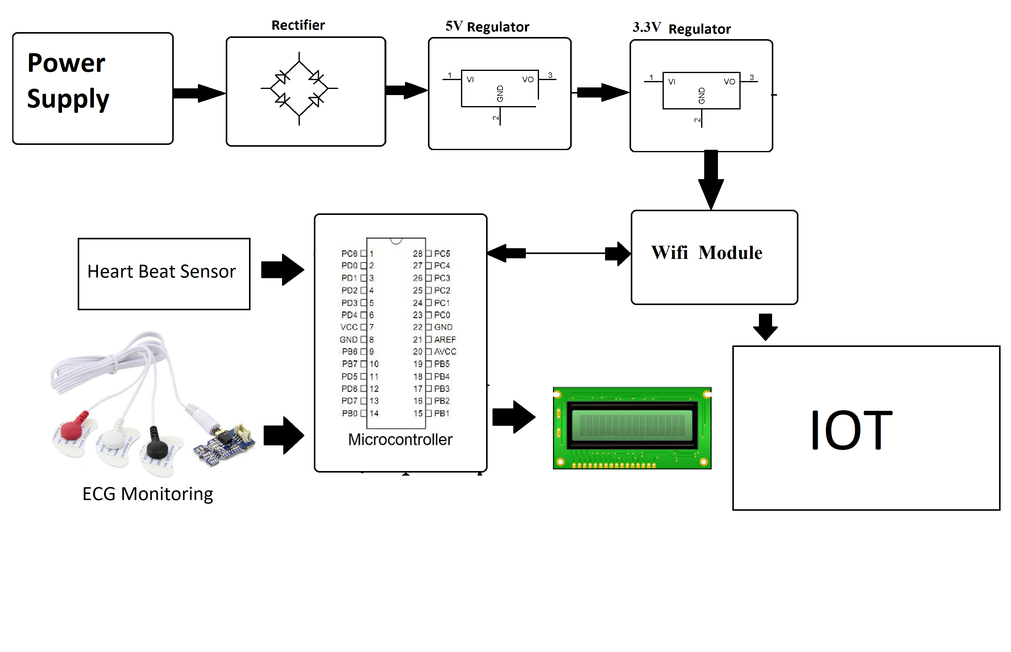

Hardware Specifications

- Avr Microcontroller
- Wifi Module
- Crystal Oscillator
- ECG Sensor
- LCD Display
- Resistors
- Capacitors
- Transistors
- Cables and Connectors
- Diodes
- PCB and Breadboards
- LED
- Transformer/Adapter
- Push Buttons
- Switch
- IC
- IC Sockets

Software Specifications

- Arduino Compiler
- Programming Language: C

